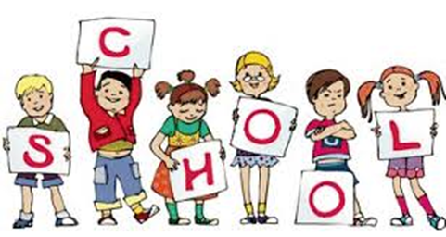

Cloverleaf Local Schools
Parent and Community Involvement Plan

Parents, teachers, other school staff and students will share the responsibilities for improved student academic achievement. The school and families will continue to build and develop a partnership to help children achieve.



What is Title 1?

Cloverleaf Elementary is a Targeted Assistance Title 1 School. What does “Targeted Assistance Title 1” mean? The Title 1 Targeted Assistance Program is a federally funded supplemental education program that provides financial assistance to our school district for the purpose of improving educational opportunities for children who need additional assistance to increase their academic skills. At Cloverleaf, the Title 1Targeted Assistance Program is designed to help children meet the State Learning Standards in reading and/or mathematics depending on each child’s individual needs.

Professional Development

Every Title I teacher/tutor in the Cloverleaf Local School District is a certified/licensed teacher. Teachers participate in professional development activities throughout the school year designed according to state professional development standards.

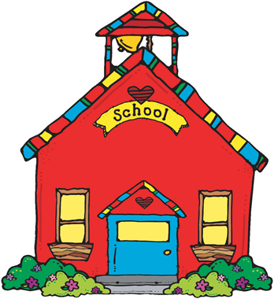

Parent Involvement

At Cloverleaf Elementary, a Title 1 school, parents and community members are welcome and invited to participate and provide input in the various activities and involvement options we have at our school. We believe that active parent/community involvement is essential to ensure student academic success. The following is a list of opportunities/activities for our school:

During each school year, we will have a Family Literacy Night. These nights will focus primarily on the English language arts. However, various other learning areas often have breakout sessions including: math, social studies, science and assessment. Parents will receive updates on the latest content and teaching strategies along with helpful learning tips and activities to assist their children succeed in school. We have staff on hand to inform parents and family members of the program, develop partnerships with parents, and explain reasons for their child’s participation.

- Our District Strategic Plan has many initiatives occurring across all three buildings at this time. Committees researching best practices in classroom instruction, foreign language, integrated technology and community involvement have been or will be taking place.



- Each year, CES hosts a Preschool Curriculum Night. Families are encouraged to attend to meet the teaching staff, learn about what learning activities their child will be exposed to, and experience the classroom environment.

- At the annual Kindergarten Open House in August, the Scavenger Hunt has become a popular activity. We encourage entire families to come enjoy our school, learning about what all day kindergarten is like, and enjoy a the scavenger hunt!

- During the CES Annual Open House in August, parents are provided with information regarding school day procedures, bussing information, community supports (Boy Scouts, United Way, etc), student handbook and expectations, needs for classrooms, and we give some of the curricular items for reading, writing, and math.

- Teachers at Cloverleaf Elementary will be conducting Parent-Teacher Conferences in October, November, and March. The purpose of these conferences is to provide meaningful conversation with students and parents regarding students’ academic strengths and to set academic goals and plans for the current school year. This is a wonderful opportunity to ask questions, examine performance data, and celebrate successes with your child.

- Parents may receive other assessment reports throughout the year that inform them on their child’s progress towards their academic goals.
Each individual classroom has its own method of utilizing parent support depending on the needs of that particular classroom.

- Parent/Community volunteers are always welcome at Cloverleaf Elementary.

